

Proactive CCTV Review
  - User Help Guide
Purpose
This guide explains how to create, edit, review, generate, and download proactive CCTV review reports in the Storm Water Asset Intelligence Portal.

Audience: Proactive Team reviewers, managers, administrators, and support staff.
Updated: July 13, 2026

Contents
Contents 2
1. Get Started 3
1.1 Sign in to the Portal 3
1.2 Open Proactive CCTV Review 3
2. Report Workspace and Lifecycle 4
Report action reference 4
2.1 Status rules 5
3. Create a New Report 5
3.1 Search by project or address 6
3.2 Select an inspection date 6
4. Review Pipes and Observations 7
4.1 Pipe and inspection details 7
4.2 Observation table 8
4.3 Confirm or score each distance group 8
4.4 Assign defect roles 9
4.5 Select snapshots 9
4.6 Record clogging and capture a frame 10
4.7 Move to the next pipe 11
5. Generate and Download the Report 11
5.1 Report output rules 12
6. Review and Close a Report 12
7. Important Testing Notice 12

1. Get Started
Before you begin
Use your work email address to sign in. During testing, the default password is your employee ID. The tool uses inspection, pipe, observation, video, and snapshot records from the Portal data sources.

1.1 Sign in to the Portal
Open the Portal URL: http://10.40.68.23:5173/.
Enter your work email address.
Enter your password. For initial testing accounts, use your employee ID.
- 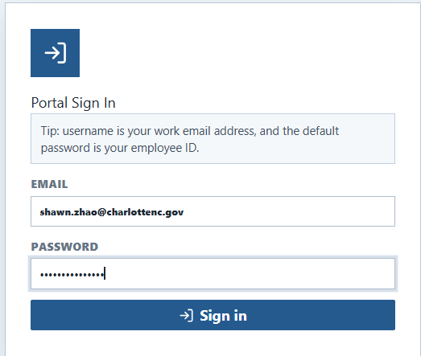
Portal sign-in page.

1.2 Open Proactive CCTV Review
From the Portal home page, open the Reports category.
Select Proactive Team CCTV Review.
The report resource opens in the Portal resource window.
- 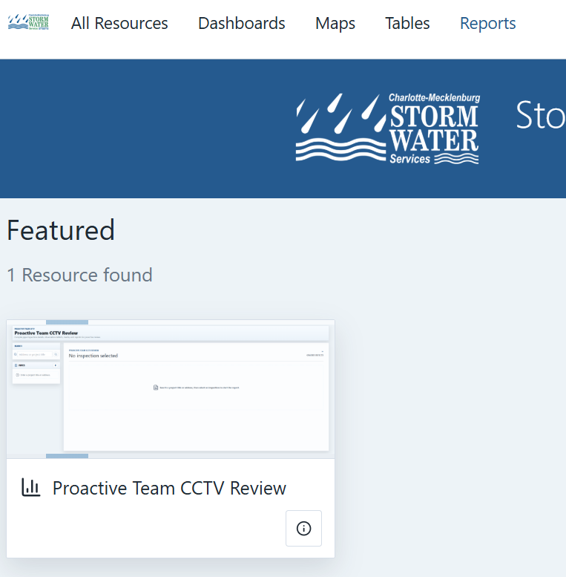
Open Proactive Team CCTV Review from the Reports category.

2. Report Workspace and Lifecycle
The landing page lists CCTV review reports. Use the filters and sort controls to find reports by binding, search text, inspection date, status, owner, reviewer, or other report metadata. The report key is managed by the system and is hidden from the main table.
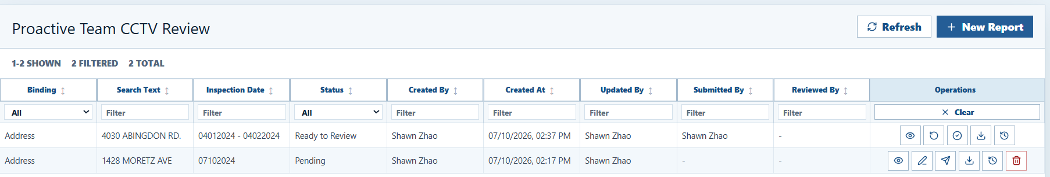
Report management table.

Report action reference
Icon | Action | When to use it
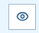 | View | Open a report without editing. Use this for completed or read-only review.
 | Edit | Open a pending report and continue the CCTV review workflow.
 | Submit to review | Move a pending report to ready to review after the reviewer has generated the report.
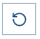 | Return to edit | Send a ready-to-review report back to pending so the owner can revise it.
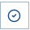 | Complete | Close the review. Completed reports are read-only.
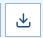 | Download | Download the current generated report file without opening the editor.
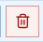 | Delete | Delete allowed pending reports. Admins and system admins can delete any report.
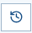 | Events | Open the report event history ordered by newest event first.

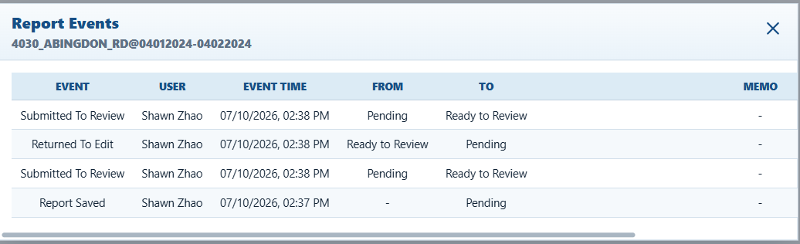
Report event history dialog.

2.1 Status rules
Pending: the report can be edited and regenerated.
Ready to Review: the report has been submitted for manager review.
Completed: the report has been reviewed and closed. Completed reports are read-only.
Only a ready-to-review report can be returned to edit.
When a report returns to pending, submitted and reviewed timestamps are cleared.

3. Create a New Report
Click New Report to open the report creation dialog. A report is created only after the user selects a project or address, selects an inspection date, and starts the report workspace.
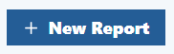
New Report button.

3.1 Search by project or address
Type a project title or address in the search box.
Use the candidate list to choose the intended project or address.
The selected search text becomes part of the report binding and report key.
- 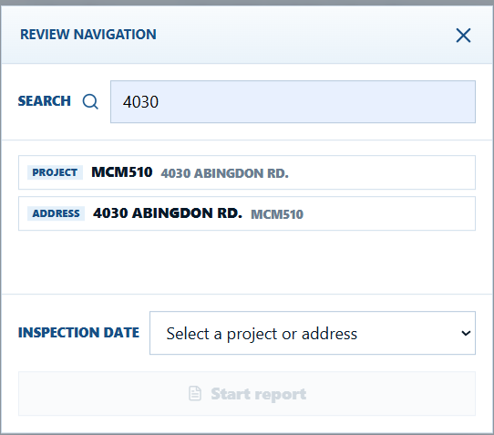
Search candidate list.

3.2 Select an inspection date
After choosing a project or address, select the inspection date or date range.
If the same report already exists, the application shows that the report has already been created.
If no duplicate report exists, click Start report to open the review workspace.
- 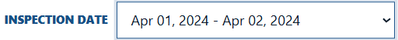
Inspection date selector.
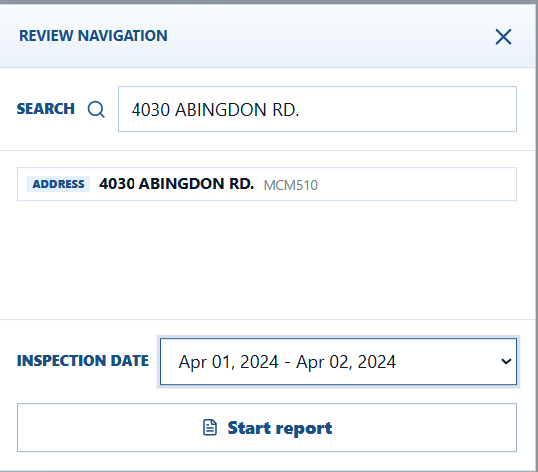
Start report dialog.

4. Review Pipes and Observations
The review workspace shows the selected pipe and inspection video on the left and the observation table on the right. Use Previous and Next to move through the pipes in the report. A report cannot be generated until every pipe has been reviewed or confirmed.
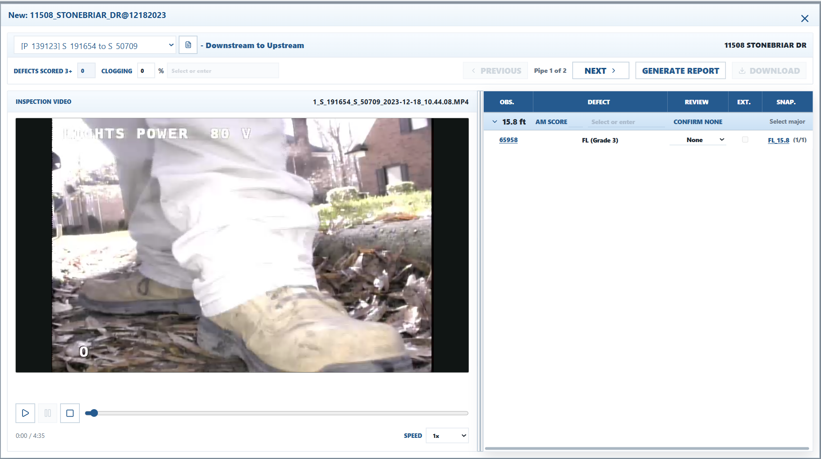
CCTV review workspace with video and observation table.

4.1 Pipe and inspection details
Use the pipe selector to move among pipes included in the report.
Click the pipe information icon to view asset details.
The inspection direction and selected pipe are displayed in the workspace header.
- 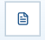
Pipe information button.
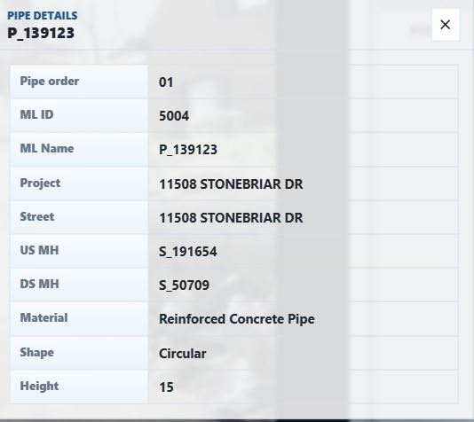
Pipe details dialog.

4.2 Observation table
Observations are grouped by distance.
Only graded defects are shown.
Access, Vermin, and Misc observation text patterns are excluded.
Click an observation ID to view observation details.
Click an observation row to seek the video to the observation time.
- 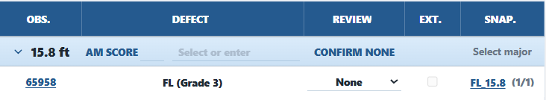
Observation rows and video seek behavior.
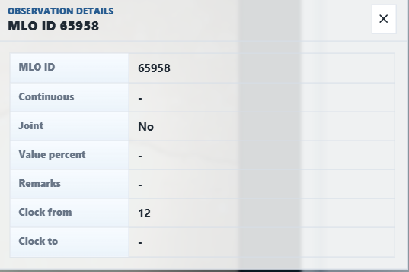
Observation detail dialog.

4.3 Confirm or score each distance group
If no defect in a distance group has AM score greater than or equal to 3, click Confirm None.
If a distance group has a defect with AM score greater than or equal to 3, enter the AM score and choose a comment.
AM score values are entered by distance group and are typically 3 to 5.
The defects scored 3+ value is calculated from the current review selections.
- 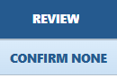
Confirm no AM score greater than or equal to 3.
AM score and comment entry.

4.4 Assign defect roles
Select Major Defect for the primary defect in a scored distance group.
Select Other Defect for additional defects at the same distance.
Other Defect should be used only when the group also has a major defect.
Use the Extensive checkbox when a selected major or other defect is extensive.
- 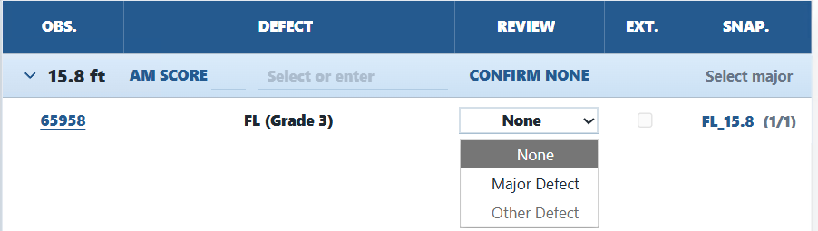
Defect role selection.

4.5 Select snapshots
Each observation can have one or more snapshots.
Click the snapshot link to choose the image that should appear in the report.
The selected snapshot file name is saved with the review data.
- 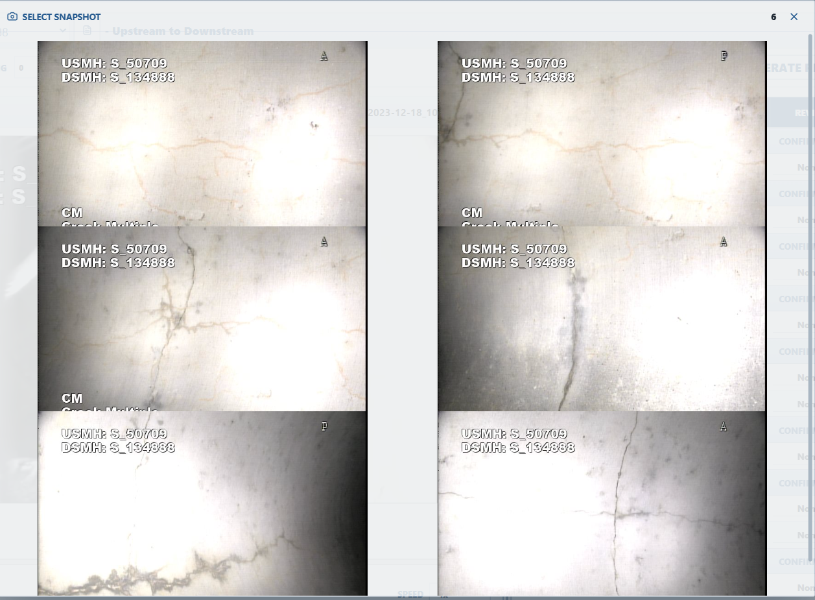
Snapshot selection workflow.

4.6 Record clogging and capture a frame
Enter the clogging percent for the current pipe.
Choose or type the clogging material or comment, such as Rocks or Deposit.
If clogging is greater than 0 percent, pause the video at the correct frame and click Capture.
Click the saved frame text to return the video to the captured time.
Clogging percent and comment controls.
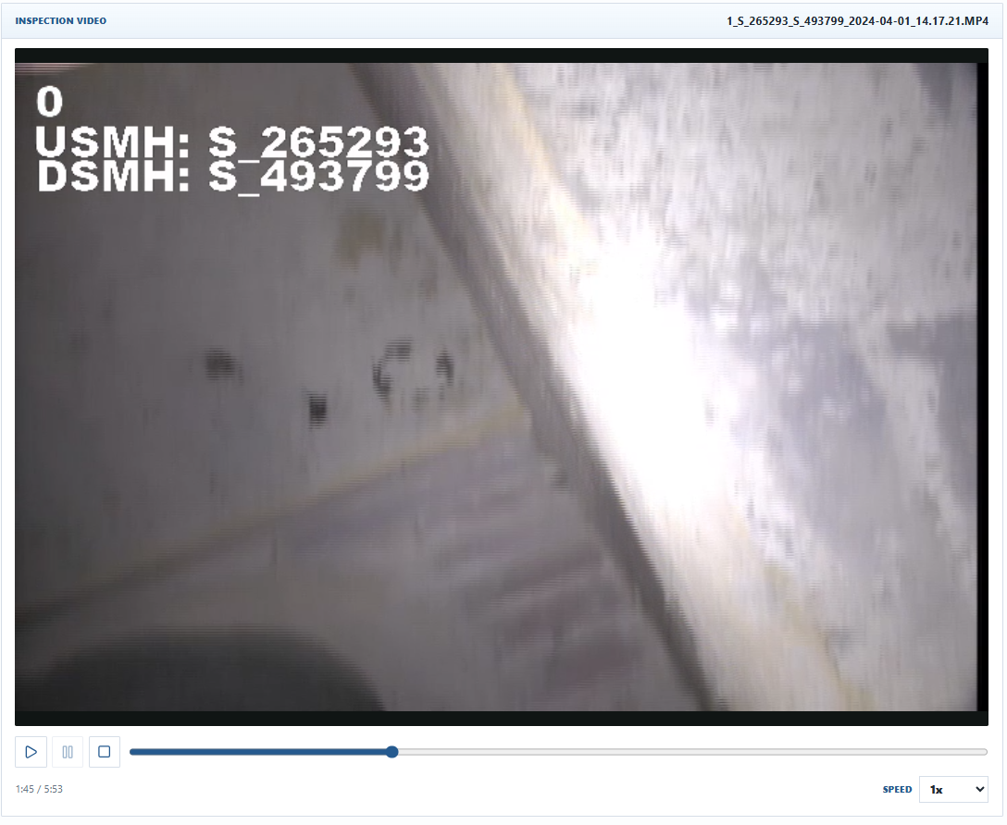
Capture current video frame for clogging.

4.7 Move to the next pipe
Click Next after the current pipe is complete.
The application checks that every unscored distance group has been confirmed.
If required confirmations are missing, a message appears and the pipe is not advanced.
- 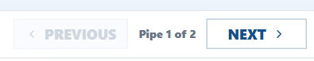
Navigation and validation message.

5. Generate and Download the Report
After all pipes have been reviewed, click Generate Report.
Enter an optional memo when prompted. The memo is saved to the report event history.
The application saves the most recent review data to the database and creates the report file.
Click Download to retrieve the generated DOCX or PDF report.
- 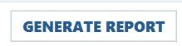
Generate Report button.
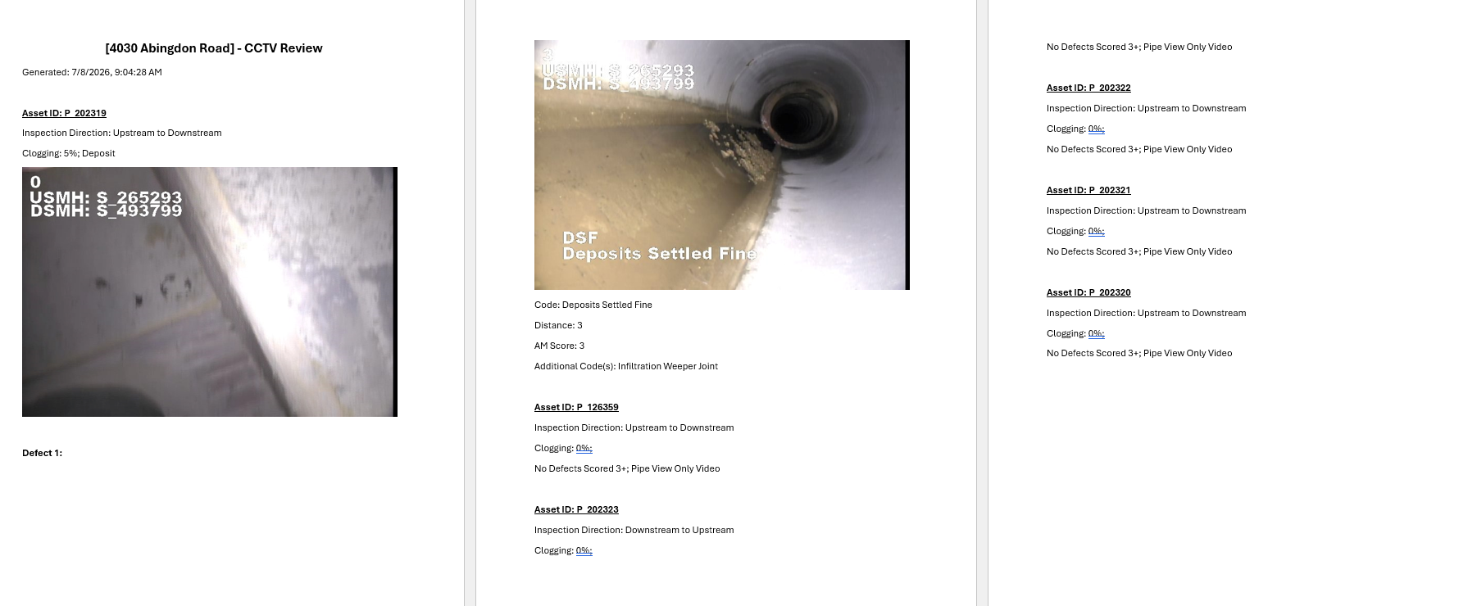
Download generated report.

5.1 Report output rules
The report title uses the selected address or project title and inspection date.
Each pipe section starts with the asset ID.
Pipes with scored defects are placed before pipes without scored defects and no clogging.
For each scored defect, the report includes the selected snapshot, code, distance, AM score, and additional codes when applicable.
If a pipe has no defects scored 3+, the report states: No Defects Scored 3+; Pipe View Only Video.

6. Review and Close a Report
Submit to review when the pending report is ready for manager review.
Managers can complete a ready-to-review report or return it to pending for edits.
Completed reports cannot be edited or returned to pending.
Use Events to see who changed a report status and when.

7. Important Testing Notice
Testing mode
This resource is still under active development and testing. Use the generated documents for review workflow testing until the team confirms that the report format is approved for official use.

